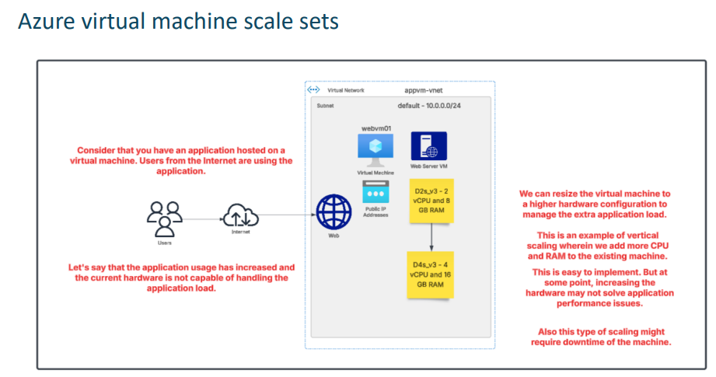

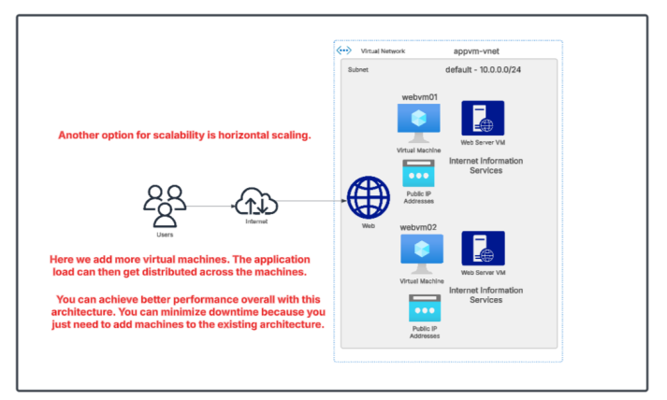

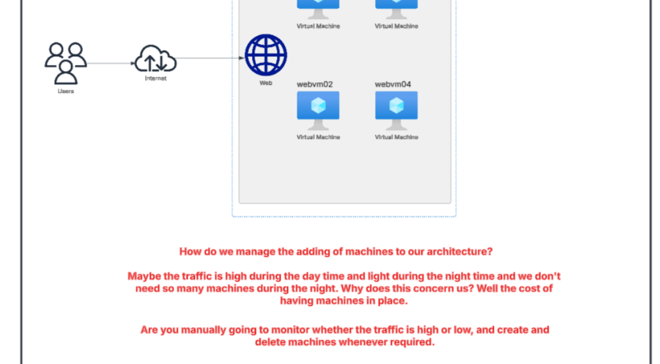

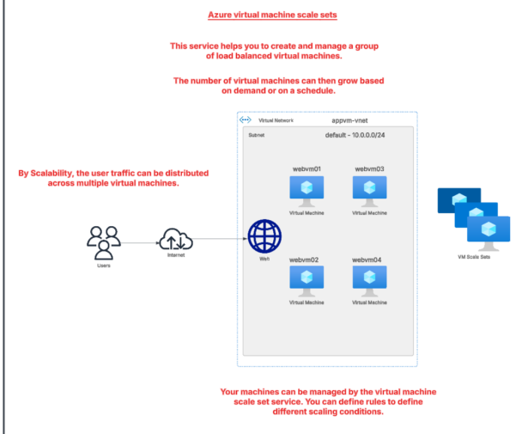

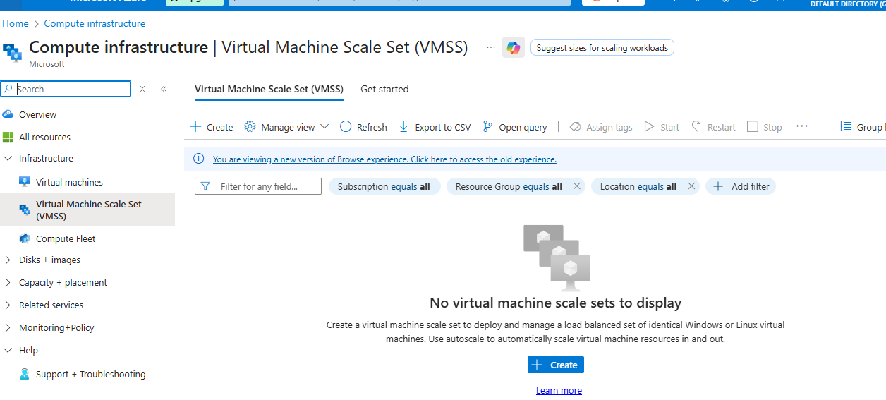

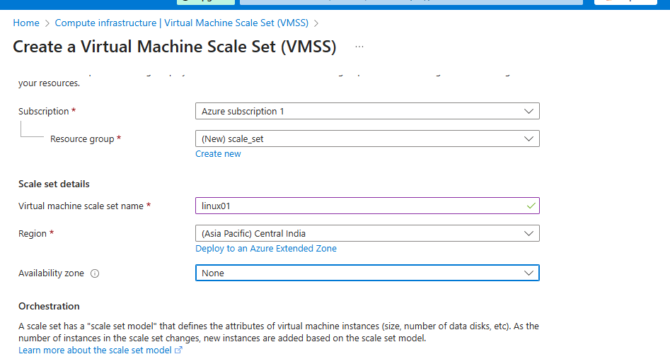

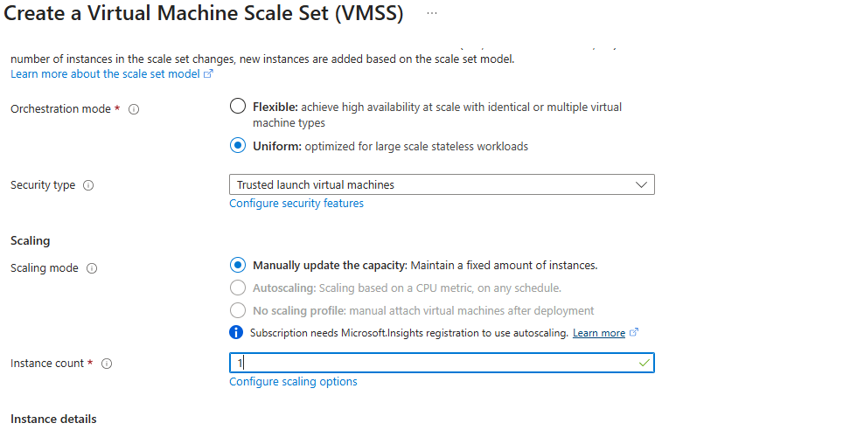

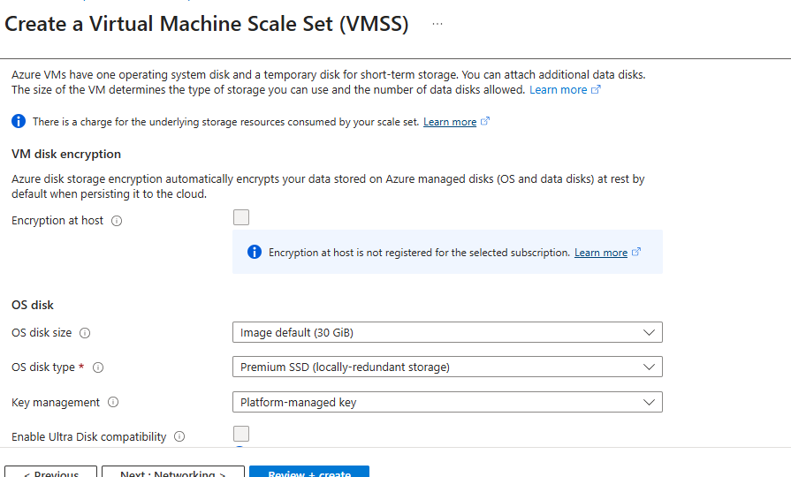

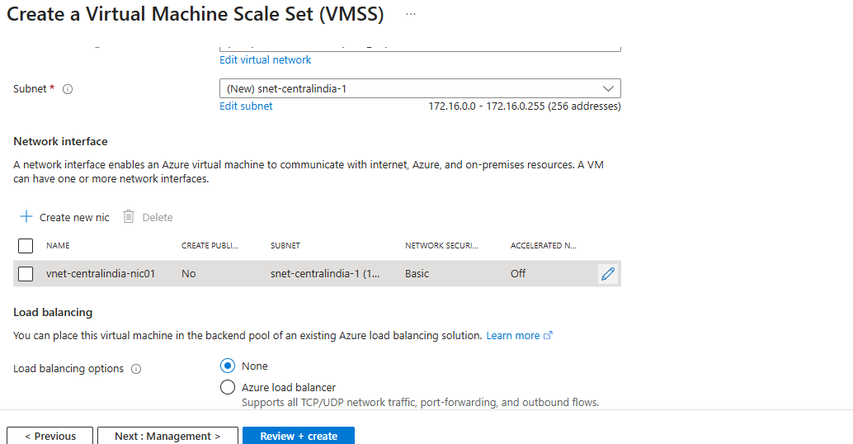

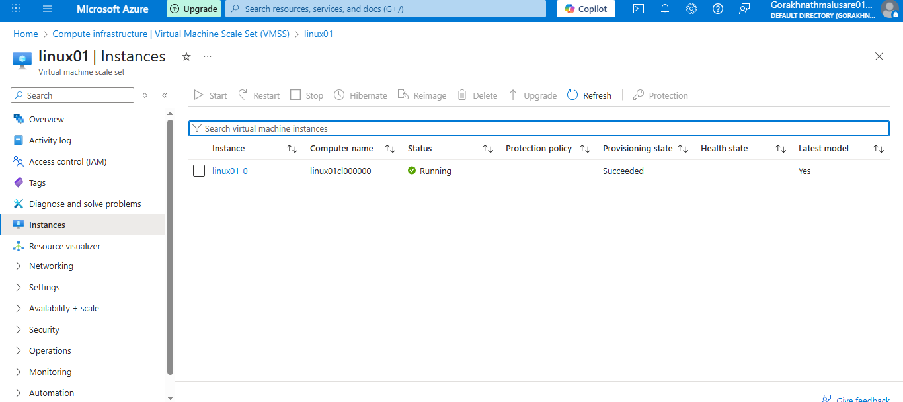

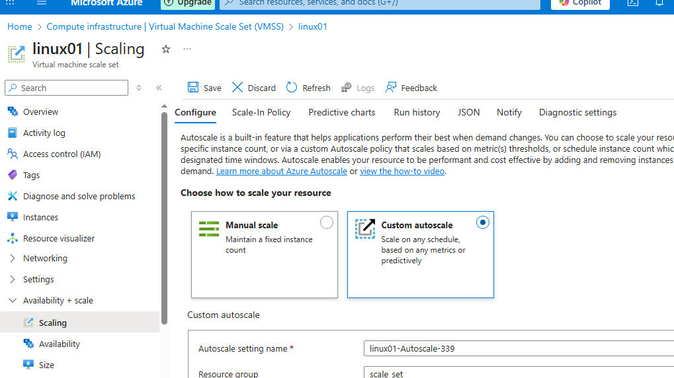

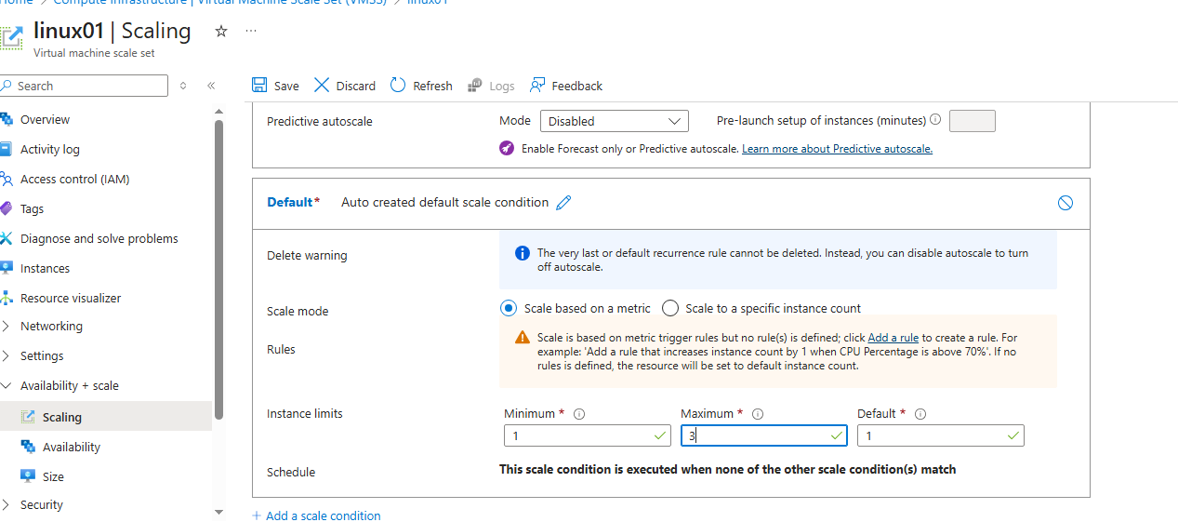

Scale out rule
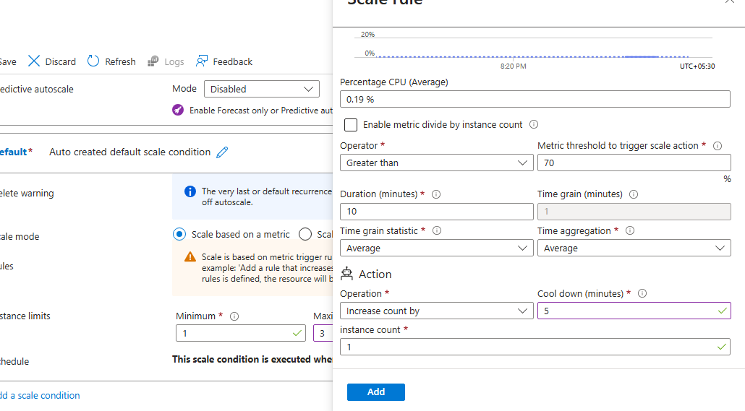
In Azure Autoscale, the Cool down period means:

✅ “Wait this much time before checking again or doing another scale action.”

Do same for scale in.

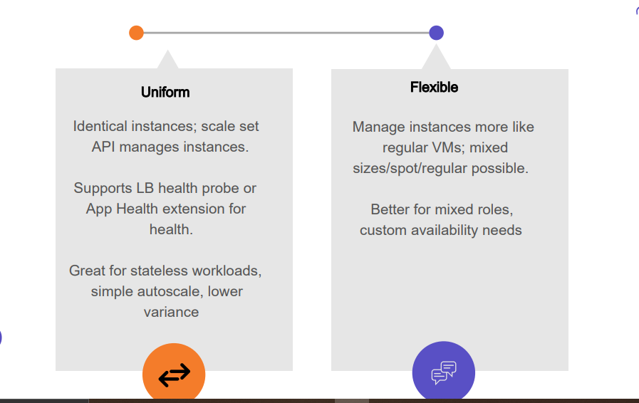

✅ VM Scale Set: Uniform vs Flexible (Very Simple Difference)

🟦 Uniform Orchestration
All VMs are identical.
✔ Same size
✔ Same image
✔ Same configuration
✔ Azure automatically distributes them across zones/Fault Domains
✔ Best for stateless web/app workloads
✔ Uses a single model → simpler scaling
✔ Load balancer integration is straightforward
Think of it like:
➡ A group of twins — all exactly same.

🟧 Flexible Orchestration
VMs can be different.
✔ Different VM sizes allowed
✔ Different OS images allowed
✔ You can manually add existing VMs
✔ Best for database clusters / domain controllers / app tiers
✔ Supports availability zone spread for ANY VM
✔ Supports mixed large + small VMs
✔ High control over placement and updates
Think of it like:
➡ A family — members can be different.

🟢 Ultra-Simple One-Line Difference

✔ Uniform = All VMs must be identical (auto-managed).

✔ Flexible = VMs can be different (custom/manual management).
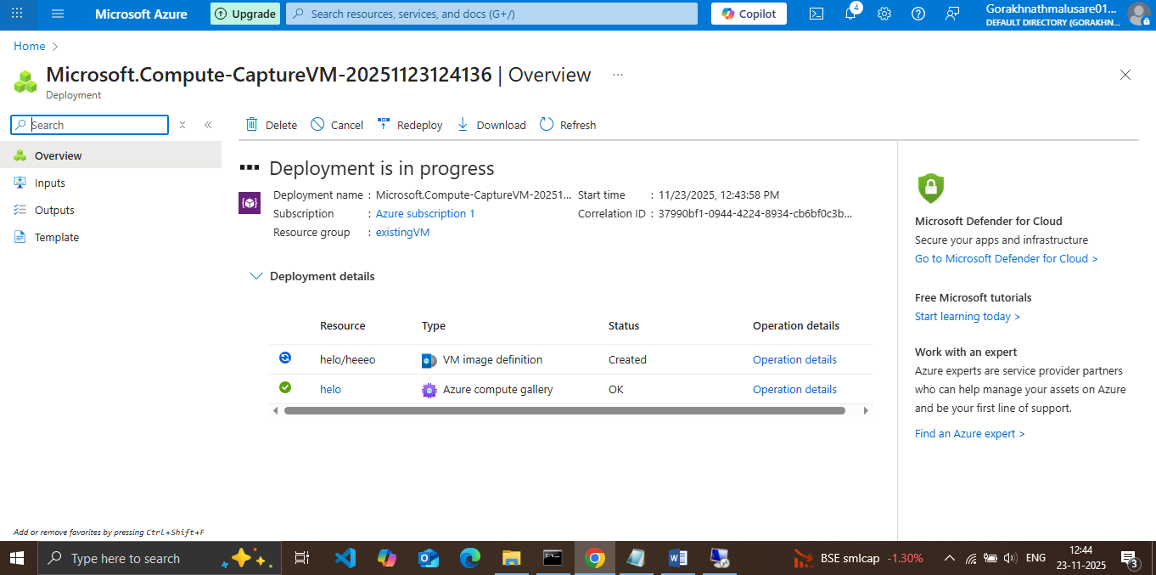

1) IMPORTANT WARNINGS (read first)
- Generalizing (Sysprep) will make the VM go through OOBE and the current machine becomes unsuitable for normal use. Back up any files, export settings, or create a snapshot before you proceed. Microsoft Learn+1
- If you need the original VM to remain available, create a copy first (create a managed image from a stopped non-generalized VM is possible but not recommended for VMSS). Best practice: snapshot/disks backup → proceed. Microsoft Learn

2) Prepare the Windows VM (inside the VM)
- RDP into your Windows VM as an administrator.
- Open File Explorer → navigate to C:\Windows\System32\Sysprep.
- Run sysprep.exe (right-click → Run as administrator).
- In the System Preparation Tool:
  - System Cleanup Action: select Enter System Out-of-Box Experience (OOBE).
  - Check the box Generalize.
  - Shutdown Options: choose Shutdown.
  - Click OK.
(The VM will generalize and then shut down.) Microsoft GitHub+1
Tip: Do not restart the VM after Sysprep. Proceed to the portal while VM is stopped/deallocated.

3) Capture the VM as a Managed Image (Azure portal)
- In the Azure portal (portal.azure.com) → top search bar type Virtual machines → select your VM.
- On the VM overview page, confirm State is Stopped (deallocated).
- On the top menu of the VM blade click Capture.
- In the Create an image blade:
  - Enter Image name (e.g., win-server-web-image-v1).
  - Resource group: choose or create as desired.
  - Check: “The virtual machine has been generalized” (since you ran Sysprep).
  - Optionally check Automatically delete this virtual machine after creating the image if you no longer need the original.
  - Click Create.
- Wait for the image resource to be created (go to Images blade to confirm). Microsoft Learn+1

4) Create a Virtual Machine Scale Set from that Image (portal)
- Portal → search Virtual Machine Scale Sets → click Create → Virtual Machine Scale Set.
- Basics tab:
  - Subscription & Resource group: pick same or new.
  - Instance details: Name your VMSS (e.g., vmss-web-prod).
  - Region: choose same region as your image and VNet.
  - Image: click the dropdown → My items → select the Managed Image you created (win-server-web-image-v1).
  - Orchestration mode: choose Uniform (instances identical).
  - Instance size: pick the VM size you need.
  - Instance count: set initial number (e.g., 2).
- Disks tab: choose managed disk type (Premium SSD for production).
- Networking tab:
  - Virtual network/subnet: choose existing VNet/subnet where your app should run.
  - Under Load balancing, select Azure load balancer. You can pick Create new or Select existing if you already have a Standard SKU load balancer. (Standard is recommended for production.)
  - If creating a new Load Balancer, the wizard will create frontend IP, backend pool and health probe automatically.
- Management tab: enable or disable Boot diagnostics; ensure Automatic OS upgrade as per your policy.
- Scaling (you can skip here and configure later) — set min/default/max instance counts if available in the wizard.
- Review + Create → Create. Wait until deployment completes. Microsoft Learn+1

5) Confirm Load Balancer & Health Probe
- Portal → Load balancers → open the load balancer created/selected.
- Under Backend pools: confirm your VMSS is in the backend pool.
- Under Health probes: verify a probe exists (typically HTTP or TCP). Note: load balancer health probes originate from IP 168.63.129.16 — ensure Windows Firewall / NSG allows probe traffic to the probe port (e.g., 80 or 443). If probe fails instances are marked unhealthy. Microsoft Learn+1

6) Configure Autoscale rules (portal)
Option A — via the VMSS blade:
- Portal → search Virtual Machine Scale Sets → select your VMSS.
- Under Settings click Scaling (or Autoscale depending on portal layout).
- Click Add autoscale setting (or Create a custom autoscale rule).
- Fill the autoscale setting:
  - Name: e.g., vmss-web-autoscale.
  - Scale based on: Metric.
  - Target resource: your VMSS.
  - Set Min / Default / Max instances (example: Min 2, Default 2, Max 8).
  - Click Add a rule:
    - Metric source: Percentage CPU (or custom metric if you have).
    - Condition: e.g., When Average CPU > 70 for 5 minutes → Scale out by +1 instance.
    - Add a scale-in rule: When Average CPU < 40 for 10 minutes → Scale in by -1 instance.
- Save the autoscale setting. Microsoft Learn+1
Option B — use Azure Monitor → Autoscale (same idea, more central control). Microsoft Learn

7) Test the setup (safe procedure)
- From VMSS blade → Instances: you will see current running instances (initial capacity).
- Test LB: open the Load Balancer frontend IP or DNS name in a browser — you should get the app served by one of the instances.
- Simulate load: temporarily change autoscale rule to a low threshold (e.g., Scale out when CPU > 5%) to force additional instances to be created quickly — do this only for a short test. After you see new instances created, revert rule and wait for scale-in.
- Check instance health: in Load Balancer → Backend pools → verify instances show Healthy based on probe. Also check VMSS Diagnostics and boot logs if instances fail. Microsoft Learn+1

8) Post-deployment checks & best practices
- Stateless app: ensure your app stores user/session data in external session store (Redis, Azure Cache) or DB — not on local disk, so new instances work correctly.
- Instance initialization: use Custom Script Extension or cloud-init (for Linux) / Windows DSC to run startup tasks on each new instance (install updates, app config). VMSS supports extensions.
- Image updates: If you update the base VM, create a new image version (or use Shared Image Gallery) and perform rolling upgrades in VMSS.
- Security: Use Standard Load Balancer + Network Security Groups and ensure probe IP and port are allowed. Microsoft Learn+1

Quick TL;DR checklist (Windows portal steps)
- Backup VM / snapshot.
- RDP → C:\Windows\System32\Sysprep → run sysprep.exe → Generalize + OOBE → Shutdown. Microsoft GitHub+1
- Azure portal → Virtual Machines → select VM → Capture → create Managed Image (mark generalized) → Create. Microsoft Learn
- Portal → Virtual Machine Scale Sets → Create → choose your Managed Image → Networking → attach/create Load Balancer → Create. Microsoft Learn+1
- After deployment: configure Autoscale rules from VMSS → Scaling (CPU or custom metrics). Microsoft Learn
- Test LB, health probe (allow probe IP 168.63.129.16), and autoscale behavior. Microsoft Learn

🟩 2) How to Start/Stop VM Automatically (on schedule)

The recommended method: Azure Automation Account + Start/Stop solution

